Customer Journey Map: HematoVision

|  |  |
| --- | --- |
| Date | 31 June 2025 |
| Team ID | LTVIP2025TMID33915 |
| Project Name | Hematovision: Advanced Blood Cell Classification |
| Maximum Marks | 4 Marks |

# Introduction

This document outlines the customer journey for the HematoVision project, detailing the steps a user (specifically a pathologist or healthcare professional) takes when interacting with the system for blood cell classification. This journey map is based on the information extracted from the project_report.pdf and provides a high-level overview of the user's experience.

# Customer Journey Stages

The customer journey for HematoVision can be broken down into several key stages:

## Stage 1: Sample Acquisition

* **User Action:** Pathologist receives a blood sample.
* **Description:** This is the initial, manual step in the process, where the physical blood sample is obtained. The project_report.pdf notes this as a "Manual process, timeconsuming."
* **Pain Points:** Time consumption, manual labor.

## Stage 2: Image Capture

* **User Action:** Pathologist captures digital images of blood cells.
* **Description:** After receiving the sample, the pathologist uses microscopy and imaging equipment to convert the physical blood cell information into digital images. These images will serve as the input for the HematoVision system.
* **Key Considerations:** Image quality, resolution, and consistency are crucial for accurate downstream analysis.

## Stage 3: Image Upload

* **User Action:** User uploads images to the HematoVision web application.
* **Description:** The digital images captured in the previous stage are then uploaded to the HematoVision web application. This typically involves interacting with the home.html interface, selecting the image files, and initiating the upload process.
* **Touchpoints:** HematoVision web application ( home.html ).
* **Goals:** Easy and efficient image submission.

## Stage 4: Image Processing and Classification

* **System Action:** The HematoVision backend processes the uploaded image and performs classification.
* **Description:** Once uploaded, the app.py backend takes over. It utilizes the machine learning model ( model.ipynb ) to analyze the blood cell images and classify them into their respective types (e.g., Eosinophil, Lymphocyte, Monocyte, Neutrophil). This stage is largely automated and happens behind the scenes from the user's perspective.
* **Key Technologies:** Flask backend ( app.py ), Machine Learning Model ( model.ipynb ).
* **User Expectation:** Fast and accurate classification results.

## Stage 5: Result Display

* **User Action:** User views the classification results.
* **Description:** After the processing and classification are complete, the results are presented to the user on the result.html page. This includes the predicted blood cell type and potentially other relevant information such as confidence scores or visual annotations.
* **Touchpoints:** HematoVision web application ( result.html ).
* **Goals:** Clear, understandable, and actionable presentation of results.

# Summary of Customer Journey

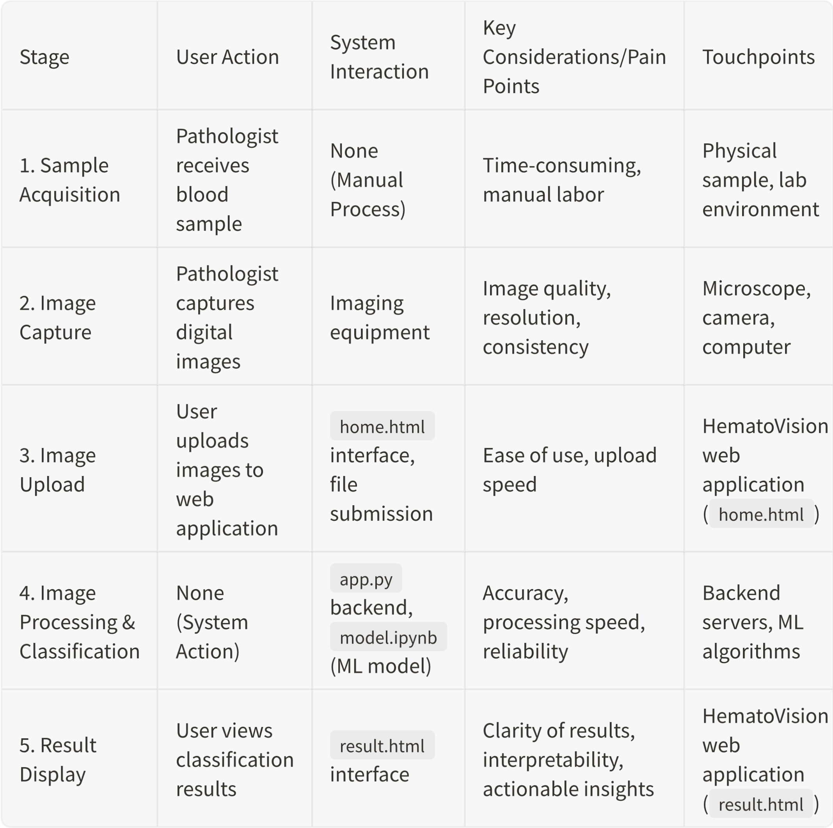

# Conclusion

This customer journey map highlights the critical interaction points between the user and the HematoVision system. By automating the image processing and classification stages, HematoVision significantly reduces the manual burden and potential for error in blood cell analysis. While the initial stages of sample acquisition and image capture remain manual, the seamless digital workflow from image upload to result display provides a valuable tool for healthcare professionals, enhancing efficiency and accuracy in their work.